Functions

* It is the block of code
* Used to perform some specific task
* It is reusable

1. **Types of functions**
2. Standard function / function declaration
3. Function expression
4. IIF (Immediately Invocable Function)
5. Arrow function

**Syntax of functions**

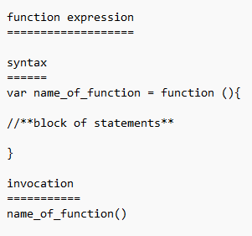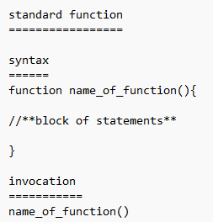

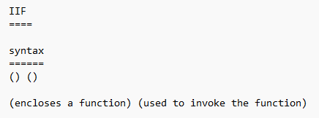

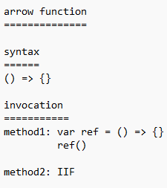

**Function declaration**

* Function declaration is the traditional way to define function.
* We start declaring a function by using the keyword “function”, followed by function name and then we can pass the parameters(optional)

**Function expression**

* We define a function using a variable and store the returned value in that variable.
* The whole function is an expression and the returned value is stored in variable.
* We use the variable name and call the function.
* When we have to invoke a function in another file (.js file), we have to go for function expression.

**IIF (Immediately invocable function)**

* This function is rarely used
* ()()==>2 invocations. In 1 invocation we will enclose the function and another invocation symbol is used to invoke the function
* Only one IIF can be used in one .js file. If we use more than one IIF we will get an error

**Arrow function**

* Arrow function was introduced in ES6 version of JavaScript.
* This function is mainly used for code optimisation.
* In a single line of code, the function returns implicitly.
* When there are multiple lines of code we use brackets. When there are multiple lines of code in the bracket we should write return explicitly to return the value from the function.